**Smart Attendance Capturing System**

1. **Abstract**

Face recognition is one of the mostly used biometrics. It can used for security, authentication, identification, and has got many more advantages. Despite of having low accuracy when compared to iris recognition and fingerprint recognition, it is being widely used due to its contactless and non-invasive process. Furthermore, face recognition system can also be used for attendance marking in schools, colleges, offices, etc. This system aims to build a employee attendance system which uses the concept of face recognition as existing manual attendance system is time consuming and cumbersome to maintain. And there may be chances of proxy attendance. Thus, the need for this system increases. This system consists of four phases- database creation, face detection, face recognition, attendance updation. Database is created by the

images of the employees in company. Face detection and recognition is performed using Haar - Cascade classifier and Local Binary Pattern Histogram algorithm respectively. Faces are detected and recognized from live streaming video of the classroom.

Keywords—Face Recognition; Face Detection; Haar-Cascade classifier; Local Binary Pattern Histogram; attendance system;

1. **INTRODUCTION**

Traditional method of attendance marking is a tedious task in many companies. It is also an extra burden to the manager who should mark attendance by manually calling the names of company which might take about 5 minutes of entire session. This is time consuming. There are some chances of proxy attendance. Therefore, many companies started deploying many other techniques for recording attendance like use of Radio Frequency Identification (RFID) [3], iris recognition [4], fingerprint recognition, and so on. However, these systems are queue based which might consume more time and are intrusive in nature.

Face recognition has set an important biometric feature, which can be easily acquirable and is non-intrusive. Face

recognition based systems are relatively oblivious to various facial expression. Face recognition system consists of two categories: verification and face identification. Face verification is an 1:1 matching process, it compares face image against the template face images and whereas is an 1:N problems that compares a query face images [1]. The purpose of this system is to build a attendance system which is based on face recognition techniques. Here face of an individual will be considered for marking attendance. Nowadays, face recognition is gaining more popularity and has been widely used. This new system will consume less time than compared to traditional methods.

1. LITERATURE SURVEY

Authors in [3] proposed a model of an automated attendance system. The model focuses on how face recognition incorporated with Radio Frequency Identification (RFID) detect the authorized employees and counts as they get in and get out form the company. The system keeps the authentic record of every registered employee . The system also keeps the data of every student registered for a particular course in the attendance log and provides necessary information according to the need.

In this paper [4], authors have designed and implemented an attendance system which uses iris biometrics. Initially, the attendees were asked to register their details along with their unique iris template. At the time of attendance, the system automatically took company attendance by capturing the eye

image of each attendee, recognizing their iris, and searching for a match in the created database. The prototype was web based.

In [5], authors proposed an attendance system based on facial recognition. The algorithms like Viola-Jones and Histogram of Oriented Gradients (HOG) features along with Support Vector Machine (SVM) classifier were used to implement the system. Various real time scenarios such as scaling, illumination, occlusions and pose was considered by the authors. Quantitative analysis was done on the basis of Peak Signal to Noise Ratio (PSNR) values and was implemented in MATLAB GUI.

Authors in [6] researches to get best facial recognition algorithm (Eigenface and Fisher face) provided by the Open CV 2.4.8 by comparing the Receiver Operating Characteristics (ROC) curve and then implemented it in the attendance system. Based on the experiments carried out in this paper, the ROC curve proved that, Eigenface achieves better result than Fisher face. System implemented using Eigenface algorithm achieved an accuracy rate of 70% to 90%.

In [7], authors proposed a method for student attendance system in company using face recognition technique by

combining Discrete Wavelet Transforms (DWT) and Discrete

Cosine Transform (DCT). These algorithms were used to

extract the features of student’s face followed by applying

Radial Basis Function (RBF) for classifying the facial objects. This system achieved an accuracy rate of 82%.

1. PROPOSED SYSTEM

All the employees of the company must register themselves by entering the required details and then their images will be captured and stored in the dataset. During each shift’s, faces will be detected in company. The faces detected will be compared with images present in the dataset. If match found, attendance will be marked for the respective employee. The system architecture of the proposed system is given below,

Typically this process can be divided into four stages,

**1. Dataset Creation**

We have use MYSQL workbench for making data of peoples for storing our data in proper format in rows and columns.

And for storing data of images, we create a folder for this and give the folder name as data and all the images will be stored in this folder. We can store 100 images of 1 person and also train this image by trainer.

1. **Face Detection**

Person face can be detected by this system and attendance can be marked by this firstly, a person can register and login into the system and give the image and this image is capture by the web camera of system with the help of open CV library in python also by using Har cascading style sheet and in this system when the user can come on the front of the camera so the user’s name, id and other details are display on the screen and their attendance can be marked by this.

3. Face Recognition

Our Face recognition process can be divided into three steps-

Taking sample of the users, prepare training data, train face recognizer. Here training data will be the images present in our dataset.in data set we give an integer value to each users. These images are then used for face recognition. Face recognizer used in this system is Local Binary Pattern Histogram. Initially, the list of local binary patterns (LBP) of entire face is obtained.

1. Attendance Updation

After face recognition process, the recognized faces will be marked as present in the excel sheet and the rest will be marked as absent and the list of absentees will be mailed to the respective faculties. Manager will be updated with monthly attendance sheet at the end of every month.

1. RESULTS AND DISCUSSIONS

The users can interact with the system using a GUI. Here users will be mainly provided with three different options such as, employee registration, other workers registration, and mark attendance. The company are supposed to enter all the required details in the employee registration form. After clicking on register button, the web cam starts automatically and window as shown in Fig.3. pops up and starts detecting the faces in the frame. Then it automatically starts clicking photos until 60 samples are collected or CRTL+Q is pressed. These images then will be pre-processed and stored in

training images folder. The manger are supposed to register with the respective department codes along with their email-id in the manager registration form provided. This is important because the list of absentees will be ultimately mailed to the respective managers.

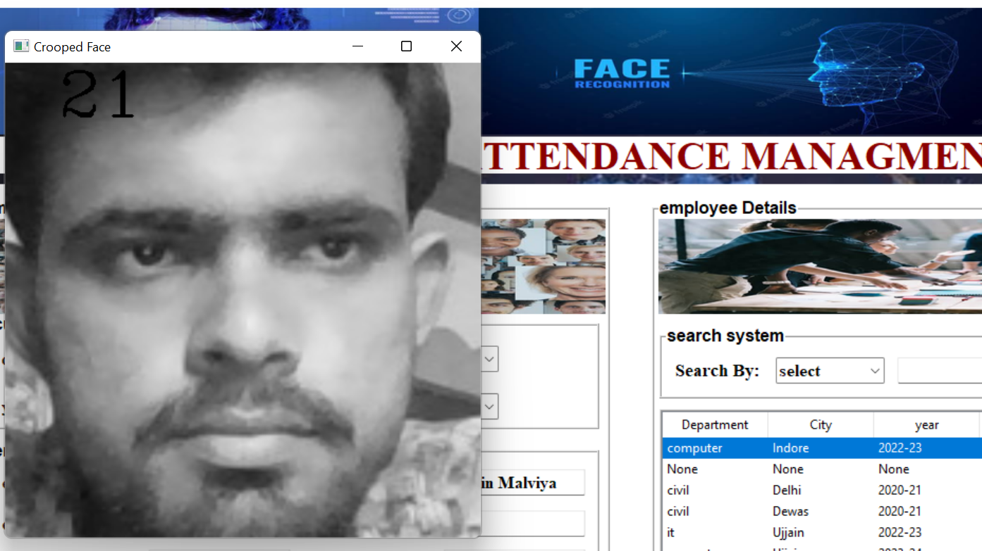

In every session, respective mangers must enter their department code. Then after submitting the department code, the camera will start automatically. The Fig.4. shows the face recognition window where two registered employee are recognized and if in case, they were not registered it would have shown

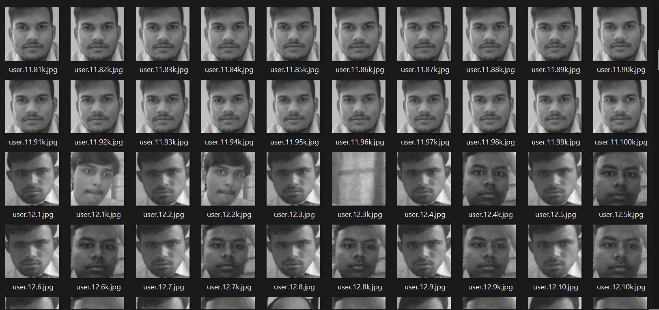

The Fig.5. shows the attendance sheet updated after

recognition process. Recognized students are marked as ‘1’

and absent students are marked as ‘0’. The list of absentees

will be mailed to the respective employee email-id

V.CONCLUSION

This system aims to build an effective company attendance system using face recognition techniques. The proposed

system will be able to mark the attendance via face Id. It will detect faces via webcam and then recognize the faces. After recognition, it will mark the attendance of the recognized employee and update the attendance record.

REFERENCES

[1]ttps://www.researchgate.net/publication/326261079_Face_detection_system_for_attendance_of_company’_employes

[2] Hapani, Smit, et al. "Automated Attendance System Using Image Processing." 2018 Fourth International Conference on Computing Communication Control and Automation (ICCUBEA). IEEE, 2018.

[3] Akbar, Md Sajid, et al. "Face Recognition and RFID Verified

Attendance System." 2018 International Conference on Computing, Electronics & Communications Engineering (iCCECE). IEEE, 2018.

[4] Okokpujie, Kennedy O., et al. "Design and implementation of a student attendance system using iris biometric recognition." 2017 International Conference on Computational Science and

Computational Intelligence (CSCI). IEEE, 2017.

[5] Rathod, Hemantkumar, et al. "Automated attendance system using

machine learning approach." 2017 International Conference on

Nascent Technologies in Engineering (ICNTE). IEEE, 2017 ; "Implementation of face recognition algorithm for biometrics based time attendance system." 2014

International Conference on ICT For Smart Society (ICISS). IEEE,

2014.